Online House Rent Finder System
for CODETREE
Shihab Mirza
#21203035

Tonmoy Sarker
#22203004

A Practicum in the Partial Fulfillment of the Requirements
for the Award of Bachelor of Computer Science and Engineering (BCSE)

Department of Computer Science and Engineering
College of Engineering and Technology
IUBAT—International University of Business Agriculture and Technology
Spring 2026

Online House Rent Finder System
for CODETREE
Tonmoy Sarker

A Practicum in the Partial Fulfillment of the Requirements for the Award of Bachelor of Computer Science and Engineering (BCSE)
The practicum has been examined and approved,

_____________________________
Prof. Dr. Utpal Kanti Das
Chairman

_____________________________
Shahinur Alam
Co-supervisor, Coordinator and Assistant Professor

_____________________________
Faniyam Maria Mansia
Supervisor and Lecturer of dept. of CSE

Department of Computer Science and Engineering
College of Engineering and Technology
IUBAT—International University of Business Agriculture and Technology
Spring 2026
Letter of Transmittal

10 May 2026
The Chair
Practicum Defense Committee
Department of Computer Science and Engineering
IUBAT—International University of Business Agriculture and Technology
4 Embankment Drive Road, Sector 10, Uttara Model Town
Dhaka 1230, Bangladesh.

Subject: Letter of Transmittal.

Dear Sir,
With due respect, I like to notify you that it gives me tremendous pleasure to complete my practicum course CSC490 by submitting the following report on the title: " Online House Rent Finder System for CODETREE"

It was pleasure to work on this project. It allowed me to increase my knowledge and experience in software engineering.

Now I'm looking forward to your thoughtful comments on this report.

Yours sincerely,
_____________
Tonmoy Sarker
22203004

Organization’s Certificate



Student’s Declaration

I, Tonmoy Sarker, a student of the BCSE (Bachelor of Computer Science and Engineering) program under the College of Engineering and Applied Technology (CEAT) at the International University of Business Agriculture and Technology (IUBAT), hereby declare that the practicum report entitled “Online House Rent Finder System for CODETREE” has been prepared as a partial fulfillment of the requirements for the completion of the course CSC490 and the degree of Bachelor of Computer Science and Engineering.
I further declare that this report is the result of my own original work and has not been submitted previously, either in whole or in part, to any other institute or organization for any academic qualification or professional purpose.

_____________
Tonmoy Sarker
22203004

Supervisor’s Certification

This is to certify that the Practicum report titled “Online House Rent Finder System” has been completed by Tonmoy Sarker (ID: 22203004), student of IUBAT – International University of Business Agriculture and Technology, as part of his CSC490 Practicum course requirements.
The report has been prepared under my supervision and serves as a documented record of his work, which has been successfully completed. He is now permitted to submit the report. I extend my best wishes for his future endeavors.

_______________________________
Faniyam Maria Mansia
Supervisor and Lecturer
Department of Computer Science and Engineering
IUBAT—International University of Business Agriculture and Technology
Abstract
In this practical report, a description is made about the development of the Online House Rent finder System. It is a web application developed with an aim to make the process of House Rent Finder System fully digitalized with improved efficiency. This has been developed as a part of the undergraduate program in Computer Science and Engineering from IUBAT—International University of Business Agriculture and Technology with a clear motive to overcome the conventional manual as well as semi-digital process for House Rent . The project involves three primary types of users, including Administrator, Owner, and User. The Administrator is expected to handle all functions of the entire sytem, including users, owners, flats listings, booking records, as well as payments. The Owner is expected to perform tasks such as creating, as well as managing, flat details, viewing booking requests, as well as managing related activities of flats being rented. The User is capable of creating logins, viewing available flats, placing booking requests, viewing booking history, as well as managing user profiles, with online payments via SSL Commerz. It was developed using HTML and CSS for front-end design, PHP for server-side processing, and MySQL for database management. The architecture is modular, scalable, maintainable, flexible, and easy to expand. It also focuses on usability, having a responsive and user-friendly interface. Special care has been taken to implement certain inbuilt security features, including session management, form validation, role-based access control, and prevention of duplicate bookings. This project provided valuable practical experience in web development, database design, authentication mechanisms, and online payment integration. System testing confirmed the reliability and effectiveness of the core modules, especially for booking and payment processing. Overall, the Online House Rent Finder System offers a modern, secure, and efficient digital solution to rental management by reducing the administrative workload, while improving convenience for users. The project demonstrates the successful application of academic knowledge to solve real-world problems through software development.

Acknowledgments

Many thanks to honorable late Prof Md M. Alimullah Miyan sir, Prof. Dr. Abdur Rab Miah sir, Prof Dr. Utpal Kanti Das sir, Rashedul Islam sir, Shahinur Alam sir and specially our supervisor, Faniyam Maria Mansia madam, for your patience, guidance and support. I have benefited greatly from your wealth of knowledge, detailed feedback and meticulous suggestions. I am extremely grateful that you took me on as student and continued to have faith in me over the period.
Thank you to Almighty god for giving me good health and strength to contributing on my project. Also, thanks to my parents for giving me support an encouraging me for stepping ahead. I extend my heartfelt thanks for their unwavering support. They've been there to listen to our rants, discuss ideas, proofread diligently, infuse humor, and make crucial sacrifices for my shared practicum success. Also, thanks to my organizational supervisor for guiding me with knowledge and experience.

Table of Contents
Letter of Transmittal .......................................................................................................... iii
Organization Certificate .................................................................................................... iv
Student’s Declaration ........................................................................................................ v
Supervisor’s Certification ................................................................................................. vi
Abstract ............................................................................................................................. vii
Acknowledgments ........................................................................................................... viii
List of Figures ................................................................................................................... xi
List of Tables ................................................................................................................... xii
Chapter 1. Introduction .................................................................................................. 1
1.1 Objectives of BCSE Program ..................................................................................... 2
1.2 Source of the Report ................................................................................................... 3
1.3 Methodologies ............................................................................................................ 3
1.3.1 Primary Sources ........................................................................................... 4
1.3.2 Secondary Sources ..................................................................................... 4
1.4 Objectives ................................................................................................................... 5
1.5 Limitations of the Project ........................................................................................... 6
1.6 Process Model ............................................................................................................ 7
1.6.1 Why This Model .................................................................................... 9
1.7 Feasibility Study ...................................................................................................... 11
1.7.1 Technical Feasibility ............................................................................ 11
1.7.2 Economic Feasibility ............................................................................. 12
1.7.3 Operational Feasibility ........................................................................ 12
2
Chapter 2. Organizational Overview ................................................................................... 14
2.1 Mission .......................................................................................................................... 15
2.2 Vision ............................................................................................................................ 15
2.3 Organization Services ................................................................................................... 16
2.4 Organization Structure ................................................................................................. 17
Chapter 3. Requirement Engineering ................................................................................ 18
3.1 Requirement Analysis ................................................................................................. 19
3.2 Requirement Engineering ............................................................................................ 19
3.2.1 User Requirements ............................................................................... 20
3.2.2 System Requirements .............................................................................. 20
3.2.3 Functional Requirements ......................................................................... 20
3.2.4 Non-Functional Requirements ............................................................... 20
3.3 Use Case Diagram of the System ................................................................................ 22
Chapter 4. Analysis .......................................................................................................... 24
4.1 Software Analysis Pattern .......................................................................................... 25
4.1.1 Why This Pattern ................................................................................... 25
4.2 ERD Diagram ............................................................................................................. 27
4.3 Activity Diagrams ...................................................................................................... 27
4.3.1 User diagram……………………………………………………………………..28
4.3.2 User flat Search booking………………………………………….……………..29
4.3.3 Owner flat management…………………………………………...……………..30
4.3.4 House Rent Payment………………………………………………….……….31
4.3.5 Admin Process………………………………………………………………………..32
Chapter 5. Project Management ........................................................................................... 33
5.1 Risk Identification Table …………………………………………................................ 34
5.2 Risk Analysis Table ....................................................................................................... 35
5.3 Risk Planning Table ....................................................................................................... 35
5.4 RMMM Plan .................................................................................................................. 36
Chapter 6. Project Planning and Scheduling ....................................................................... 38
6.1 System Project Estimation ............................................................................................ 39
6.2 Function-Oriented Metrics ............................................................................................ 40
6.3 Identifying Complexiety................................................................................................ 48
6.3.1 Identifying Complexiety of Transaction Function………………………………41
6.3.2 Identifying Complexiety of data function………………………………………41
6.3.3 Unadjusted Function Point………………………………………….………….42
6.3.4 Perfomance and Environment impact…………………….………………..……42
6.3.5 Counting Adjucted function point ……………………………………………..43
6.4 Project Schedule Chart .................................................................................................. 44
6.5 Account Table................................................................................................................ 46
Chapter 7. Designing .......................................................................................................... 47
7.1 System Architecture Design ......................................................................................... 48
7.2 Dataflow Diagram………………………………………………………….…………49
Chapter 8. Implementation .................................................................................................. 61
8.1 Tools and Technologies Used ....................................................................................... 62
8.2 Module Implementation ............................................................................................... 64
Chapter 9. Testing .............................................................................................................. 68
9.1 Testing Strategy ............................................................................................................ 69
4
9.2 Test Cases and Results ............................................................................................ 71
Chapter 10. Conclusion and Future Work .................................................................... 75
10.1 Conclusion ............................................................................................................. 76
10.2 Future Enhancement .............................................................................................. 77
References ..................................................................................................................... 84

List of Figures
Figure 1.1 Agile Process Model ............................................................................................... 8
Figure 2.1 Organization Structure ......................................................................................... 17
Figure 3.1 Use Case Diagram of the System ....................................................................... 27
Figure 4.1 ERD Diagram ...................................................................................................... 33
Figure 4.2 User Login Activity Diagram ............................................................................... 34
Figure 4.3 User Flat Search & Booking Activity Diagram …………………………........ 35
Figure 4.4 Owner Flat Management Activity Diagram ...................................................... 36
Figure 4.5 House Rent Payment Activity Diagram ........................................................... 37
Figure 4.6 Admin Control Process Activity Diagram ........................................................... 38
Figure 7.1 Home Page Design ........................................................................................... 55
Figure 7.2 Data Flow Diagram……………………..………………………………………56

List of Tables
Table 5.1 Risk Identification Table ....................................................................................... 34
Table 5.2 Risk Analysis Table ............................................................................................. 35
Table 5.3 Risk Planning Table ............................................................................................ 35
Table 6.1 System Project Estimation ................................................................................. 39
Table 6.2 Transition Function Complexity ........................................................................ 41
Table 6.3 Data Function Complexity ................................................................................... 41
Table 6.4 Project Schedule Chart ........................................................................................ 44
Table 6.5 Personnel Cost .................................................................................................... 45
Table 6.6 Hardware Cost .................................................................................................... 55
Table 8.1 Test Case 1 …………………………………………………………………….65
Table 8.1 Test Case 2 …………………………………………………………………….67

Chapter 1
Introduction

In the current fast-paced technological world, technology is an inherent element of almost every function that we conduct in our day-to-day lives. As a computer science and engineering student, I have always been very interested in learning about the formation, development, and implementation of software systems in solving everyday problems. This practicum is not just a necessary academic requirement but also a great learning experience for implementing theoretical concepts that have been learned throughout my study.
During my practicum, I was actively engaged in the development of a House Rent Finder System, which is a web-based application to make flat renting and booking processes simpler and more automated. The application primarily deals with the management of flat listings, bookings, users, owners, and safe online payment processing in an organized way. Through this, I got to apply myself in learning the practical applications related to current web technology trends such as the use of HTML, CSS, PHP, and MySQL, besides having the necessary expertise in database management, role-based access security, and the handling of secure payment transactions through the use of SSLCommerz Security Solutions.
This report highlights the knowledge gained during the course of my practicum experience, the problems faced during the process of system development, the solutions adopted to resolve the aforementioned problems, as well as my personal contributions to the project such as the addition of booking/payment features, user & owner management systems, along with the implementation of security at the level of data. This experience of doing the practicum has been very fruitful for my technical knowledge base improvement as well as learning how the actual software process of software engineering should take place.
1.1 Objectives of BCSE Program
The main aim of the Bachelor of Computer Science and Engineering (BCSE) course is to enable the students to be suitable for productive employment in the industry, academia, as well as administrative fields, through the development of their skills. This course enables the students to have the necessary analysis skills as well as the necessary competencies that help them cope against the challenges of the current technological conditions. This enables the students of the BCSE course to comprehend the analysis of the computing systems in the sector of software, hardware, as well as networking.
The BCSE curriculum provides broad theoretical foundations that strengthen the students' grasp of state-of-the-art computing concepts and methodologies. This structure allows students to identify, analyze, and solve technical problems using contemporary tools and technologies. The BCSE program falls under the College of Engineering and Technology (CEAT) and requires a total of 146 credit hours. Upon the completion of all the academic courses required in the curriculum, a student at BCSE needs to engage himself in the practicum program by interning in an organization to get hands-on experience.
IUBAT—International University of Business Agriculture and Technology gives considerable importance to the relevant training in the context of the BCSE course. Practicum, otherwise known as the project deployment phase, is an obligatory course and focuses on giving the students adequate training by implementing the concepts that they would have learned in advance or even concurrently in the areas of software development, hardware devices, and computer networking. This practice is managed by an outside organization in the form of an internship. This course lasts for a period of twelve weeks and is handled by a faculty member of the Computer Science and Engineering department.
1.2 Source of the Report
This report of the practicum is written as a significant part of the internship process at the organizational framework of the IUBAT. The internship process has been accomplished through the organization of the Codetree, since it is a web-devolopment company. But the organization has maintained the obligation of the internship relation. Finally, the esteemed faculties of the organization, Prof. Dr. Utpal Kanti Das, Chairman; Shahinur Alam, Coordinator and Assistant Professor; and Faniyam Maria Mansia, Supervisor, Department of Computer Science and Engineering, of the IUBAT, are the individuals who are accountable for the considerate discussion and monitoring of the practicum process of the institution. Your organization name has provided the opportunity to accomplish the practicum process with you and assisted in preparing this report of the practicum.

1.3 Methodologies
In this practicum, much primary and secondary data were used to complete it successfully and develop the Turf Management System. These have contributed valuable insight, technical understanding, and user-centric feedback in molding the overall functionality and usability of the platform.
Key Original Sources.
The steps of primary sources are as follows:
• Conducted informal interviews with potential users to determine problems they experience while searching for, filtering, and booking flats online.
• Collected feedback from tenants concerning difficulties while checking the availability of flats, fewer filtering options, and not being able to use secure online payments.
• Observed existing manual or semi-digital flat rental systems to find inefficiencies, errors, and delays in House Rent Finder and management.
• Performed prototype testing with selected users to refine the user interface, flat search and filtering process, and payment workflow before final implementation.
• Gained necessary insights from users and flat owners regarding desirable features and functionalities in order to help the system meet real-world needs.
• Conducted sample transactions with regard to the integration of online payment via SSLCommerz to identify any bugs for ensuring reliability.
• Collected suggestions from peers and faculty members on ways to enhance usability, navigation, and overall system design.
1.3.2 The secondary sources follow these steps:
Analyzed various documents, tutorials, and official resources available on full-stack web development, with a focus on technologies employed in this project including HTML, CSS, JavaScript, Bootstrap, PHP, MySQL, and SSL Commerz Integration.

• Explored competitive flat rental websites for understanding their functionality, user interface, as well as approaches to engage users.
• Used tutorials, blog articles, and community forum discussions in Stack Overflow, GitHub, and Dev.to to overcome specific development-related tasks and integrate best practices.
• Quoted literature from academic papers, books, and technical papers related to system design, database management, authentication, and role-based access control regarding the scalability and reliability of the system.
• Analyzed case studies on successful online booking systems and extracted effective workflows and means of error handling and improvement of user interfaces.
• Researched documentation related to integrating a payment gateway while considering security measures for the safe implementation of online payments within the system.
• Researched the optimization methods for PHP programming languages and the design principles of UI/UX to improve the system.
1.4 Objectives
"The objectives of the proposed Online House Rent Finder System have been divided into two
categories: Broad Objectives and Specific Objectives. These objectives are outlined below:
1.3.2 Broad Objective.
The broad objective of this practicum is to design and develop a user-friendly, scalable, and efficient Online House Rent Finder System, bookings, payments, and subscriptions, offering a seamless digital experience for user,owner and administrators Specific Objectives.
• Developing a centralized site where users can surf through available flats, search through locations, check the availability, as well as book online.
• To make it possible for administrators to have the ability to add and administer flat listings, user booking, owner subscription, as well as any payment data from the custom dashboard.
• Support for the integration of secure online payment services through the company 'SSLCommerz' for making bookings for flats.
• To track the bookings of flats in a real-time process and avoid discrepancies or clashes.
• In order to achieve a clean, responsive, and user-friendly design that improves the desktop and mobile user interfaces.
1.4 Limitations of the Project
While the Online House Rent Finder System offers a modern, centralized solution for managing flats, bookings, payments, and subscriptions, the project still faces certain limitations that may affect its scope, functionality, and usability in broader contexts.

Geographical Limitation:
Currently, the system is designed to served a specific region. It lacks built-in support for multiple currencies, time zones, and localization, which limits its usability for users and owners from differant regions.
Limited Payment Integration:
The system is devoloped with SSLCommerz for online transactions, which may not be supported in all areas. Support for alternative gateways like bKash, Nagad, Rocket, Sonali Bank, or direct bank transfers is available.
Dependency on Internet Connectivity:
The system is entirely web-based, meaning users and owners require consistent internet access. This can be a limitation in rural areas or locations with unstable connectivity, particularly for admins, owners, or tenants accessing the platform remotely.
Scalability Concerns:
As the number of flats, bookings, and users grows, performance optimization may become a concern unless the infrastructure is upgraded. The current architecture may need enhancements to handle high concurrent traffic efficiently.
Limited Mobile Optimization:
Although the responsive design of the interface means that the system can readily be accessed through mobile devices, a mobile application specifically for owners and tenants would increase its usability and is being developed.
Admin Dependency for Flat and Booking Management:
Admins are responsible for manually taking care of flats, bookings, and user accounts, which
may be cumbersome as it scales. The system does not have a smart and automated suggestion
or conflict resolution system.
No Real-Time Chat or Support Feature:
At the moment, the system does not offer real-time communication between any users, owners,
or admins. This affects instant support queries.
Security and Data Privacy Concerns:
As the system acquires user as well as owner data and performs the process of payment
processing, the area of data protection has remained an area of challenge.
Limited Reporting and Analytics:
There are basic report generation features related to flats, bookings, and payments. The
advanced analytical functionalities related to the occupancy trends, revenue charts, or
performance Key Performance Indicators have not been incorporated.
1.5 Process Model
To build the House Rent Finder System, I have applied the Agile Software Development Model, specifically Scrum development methodology, because of the everchanging nature of this project, which requires changing demands from users and feedback from teachers, friends, and potential users. In this case, the project demands an iterative approach that can accommodate different changes.
Agile helped me to decompose the entire project into manageable slices known as iterations or “sprints,” whereby I could concentrate on particular aspects of it, like user registration/login, managing profiles, flat listings, filtering, booking, owner subscription, and integration with SSLCommerz payments.

• It is because of this methodical, malleable approach to analysis that it is possible to ensure that what is eventually produced is refined, accessible, and important.
• Regular iterations enabled quick feedback and enhancements regarding essential functionalities.
• Adaptable to changes in requirements during the development stages, mainly from realtime feedback from users or owners.
• Enhanced collaboration and communication with fellow students, lecturers, and other stakeholders during the practicum.
• More attention could be given to the user experience, usability, as well as the interface. This could be accomplished with shorter
• Bug tracking and fixing effectively to shift to the other phase.

This below figure illustrates the process flow of agile process model –

Figure 1.1: Agile process model
1.5.1 Why This Model
Flexibility to Changing Requirements
Many results from user feedback during testing included changes to UI elements, flat search and filtering, dashboard design. Agile allowed me to move requirement changes mid-sprint without disrupting the entire development cycle—something that would not have been feasible in a rigid waterfall model.
Iterative Development with Prioritized Goals
With these sprints, it was easy to work on one functionality at a time: user login and registration functionality, profile management functionality, listing functionality, filtering/booking functionality, owner subscription functionality, and SSLCommerc payments functionality. This way, it was possible to work on manageable chunks and complete every functionality without leaving any undone.
Continuous User and Stakeholder Feedback
Through informal interviews, prototype testing, and UI/UX trials, feedback was gathered at
almost every stage. Agile made it possible to incorporate feedback quickly—for example, improving the House Rent flow after users found it confusing or simplifying the owner dashboard based on mentor suggestions.
Faster Delivery of Working Software
Agile is all about early delivery of functional components, though the product might be
incomplete. This was an important factor to consider for the practicum timeline, where for the
evaluations and presentations, I needed to show working prototypes like the booking module,
admin dashboard, and SSLCommerz payment process.
Improved Risk Management
This was enabled by testing each of the modules separately and through regular iterations.
Some possible risks included payment failure, double booking, or updating the profile wrongly.
These issues would be rectified in the early stages of development.
Greater Collaboration and Communication
Even though this is an individualized - experience, I maintained regular communication with peers and instructors, as well as test subjects. Communication, which is a key component of Agile, made it easier to follow along with progress and ensure the project met objectives.
Enhanced Product Quality
The Agile "test-as-you-go" approach meant that bugs were found out early and code was continually refined. Testing pheses would run in each sprint, and issues were usually fixed before moving to the next feature, ending up with a much more stable and user-friendly final product.
User-Centered Design Approach
Agile development is very supportive of development by and for end-users. In other words, through their connection with users, owners, and mentors, the system developed was designed not merely to work, but to also be functional and effective in their practical applications in House Rent.
Scalability for Future Enhance
As Agile development is more modular, planning for enhancement work such as mobile apps, multiple languages, analytics, and AI-driven recommendations for apartments became much simpler. Each enhancement can be implemented without affecting the existing system. Better Time and Resource Management Agile helped in keeping the project going despite academic deadlines, learning curves, and changes in requirements. Sprint planning helped set realistic goals, and retrospectives helped in constantly improving the way time and effort were allocated.
1.6 Feasibility Study
The feasibility study has been divided into three phases: technical feasibility, economic feasibility, and operational feasibility. The proposed Online House Rent Finder System is feasible in all these three phases, as discussed below:
1.6.1 Technical Feasibility
The system is built using widely used and reliable web technologies such as HTML, CSS, JavaScript, Bootstrap, PHP, Laravel, and MySQL, with integration of SSLCommerz for secure online payments. These technologies are open-source, well-documented, and supported by strong developer communities, making them ideal for building and maintaining this platform. From a technical perspective:
• The system architectured supports multiple user roles (tenant, owner, admin) with rolebased access control.
• The database design to ensures efficient management of flats, bookings, subscriptions, and payments.
• The responsive frontend ensures usability across devices, including desktops, tablets, and mobile devices.
• SSL integration ensures secures and reliable payment transactions for users and owners.
1.6.2 Economic Feasibility
• The system is cost-efficient to develop, deploy, and maintain. Key factors include.
• The technologies used (PHP, MySQL, HTML, CSS, JavaScript, Bootstrap) are opensource, eliminating licensing fees.
• Deployment and hosting can be done on low-cost shared or cloud-based services.
• SSLCommerz integration for secure payments without building custom paymentgateways.
• It saves flat owners and agencies from relying on manual methods or other third-party reservation systems that are usually very expensive.
• The system also provides revenue opportunities for owners through more bookings, better customer experience, and reduced operational overhead.
• Overall, the Online House Rent Finder System is economically feasible and has potential for long-term financial sustainability.
1.6.3 Operational Feasibility
The system is designed to be user-friendly, responsive, and efficient, making it easy for administrators, flat owners, and users to operate with minimal training.

Key operational benefits:
• Admins can maintain flat listings, manage bookings, keep track of payments, and handle owner subscriptions.
• It allows owners to sign up, log in, upload the details of flats, mark their availability, and shows all bookings accordingly.
• They can register, log in, filter flats according to location, book the same online, make secure payments, and also view their history related to booking/payment made without much hassle.Real-time booking reduces errors such as double-booking of flats.
• Automated payment and booking confirmations streamline operations and reduce manual work.
• The system is support 24/7, allowing users and owners to interact with the platform at their convenience.
Given its intuitive design, automation, and minimal human intervention after setup, the Flat
Booking Management System is highly operationally feasible for users, owners, and administrators.

Chapter 2
Organizational Overview

2.1 Organization Overview
CODETREE is a organization with a team of enthusiastic designers, developers and entrepreneurs who decided to merge their experiences together under one tree to offer the best output for the desired software/IT solution. No matter how small or how big the project is, CODETREE work on it without any hesitation. CODETREE take every project as a challenge and always try to give the best effort. CODETREE’s efforts focus on concept, design, development and re-engineering of web businesses. CODETREE are working closely with software majors on new applications for user demographics to the history of purchase decisions with instant comparisons from distributed databases.
2.2 Organization Vision
CODETREE is dedicated to crafting innovative software and IT solutions that empower businesses and individuals to thrive in the dynamic digital landscape. With an unwavering commitment to excellence, integrity, and customer satisfaction, CODETREE seeks to deliver transformative value, foster growth, and redefine possibilities in the technology-driven world. CODETREE’s mission is to equip our clients with robust, cutting-edge tools to navigate and succeed in the ever-evolving digital era. Through a diverse array of expertly designed services, we provide tailored solutions that address unique business challenges, ensuring our clients are equipped to lead in the age of technology.
2.3 Organization Mission
CODETREE aspires to be a global leader in IT innovation, thrive for delivering high-impact, user-centric digital solutions that drive business success. CODETREE aim to empower organizations with intuitive, scalable, and forward-thinking technology that fuels growth and adaptability in a fast-paced digital world. By staying at the forefront of technological advancements and continuously refining our offerings, CODETREE is committed to providing unparalleled solutions that anticipate and exceed client expectations, setting new benchmarks for excellence in the IT industry.

2.4 Organization Services
CODETREE envisions a future where technology seamlessly integrates into every facet of business and personal life, unlocking limitless potential in a connected world. As a forward-thinking IT company, CODETREE offers a comprehensive suite of premium services designed to meet the diverse needs of its clients.
    - Web Design: CODETREE delivers visually striking and highly functional website design services. Our Web Design Program equips individuals and businesses with the skills to create professional, responsive, and engaging websites that captivate audiences and elevate brand presence.
    - Web Development: Our expert team specializes in building bespoke web applications tailored to unique business requirements. CODETREE’s web development services focus on creating fast, secure, and user-friendly platforms such as ERP system or ecommerce site.
    - UI/UX Design: CODETREE provides top-tier UI/UX design services, crafting intuitive and aesthetically pleasing interfaces for websites and digital products. Our designs prioritize user satisfaction, ensuring seamless navigation and memorable experiences.
    - Software Quality Assurance (SQA): COODETREE offer free services to ensure software reliability and performance. CodeTree’s empowers professionals with the expertise to deliver flawless software solutions, minimizing bugs and optimizing functionality.
    - Digital Marketing: Our Digital Marketing Services and Training Program provide clients with cutting-edge strategies in social media marketing, content creation, SEO, email campaigns, and advertising, driving brand visibility and customer engagement in the digital space.
    - By leveraging advanced technologies such as Laravel, CODETREE delivers scalable, secure, and high-performance solutions that align with our mission to empower clients and our vision to lead the IT industry. These services, combined with our commitment to innovation and client success, position CODETREE as a trusted partner in navigating the complexities of the digital age
2.5 Organizational Structure
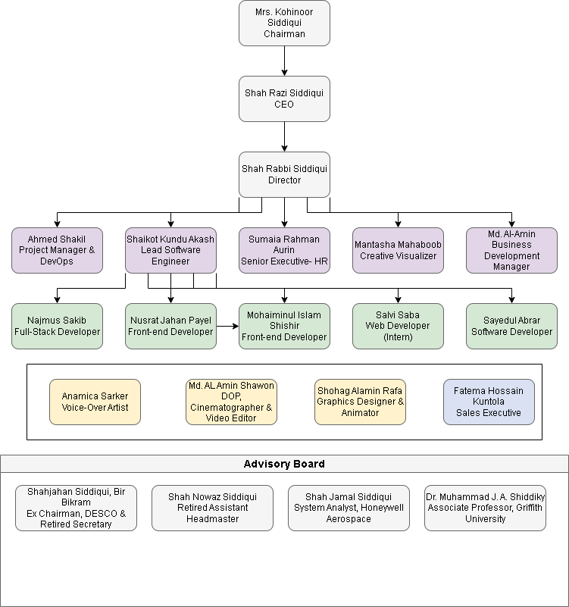
The organogram of the organization has shown in figure 2.1.
Figure 2.1 Organizational Structure
2.6 My Position in this Organization
My working position in CODETREE is Software developer intern.
2.7 Address of the Organization
Location: Flat-3A, House 73/F, Road 12/B, Sector 10, Uttara Model Town, Dhaka-1230, Bangladesh.

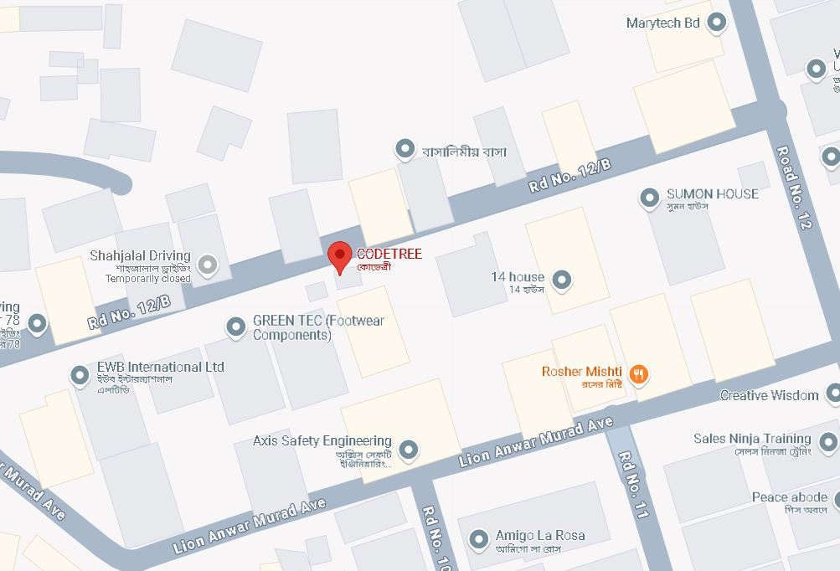

Figure 2.2 Organization location

Chapter 3.
Requirement Engineering

3.1 Requirement Analysis
Requirement analysis is the backbone of the House Rent Finder System (HRFS), since it is the process through which requirements and expectations of different people are converted into the functionalities of the proposed system. In the requirement analysis stage, the aim was to identify the shortcomings of the conventional House Rent process that entails manual registration, the absence of centralized information, conflicts in booking, and poor payment follow-ups.
In an effort to gains a better insight into these issues, informal interviews were carried out with the potential user community (tenants), the flat owners themselves, as well as individuals who interact with the management of rental properties. Furthermore, an analysis of the current flat rental systems and manual booking processes was undertaken to determine the typical issues and the expectations of the potential users.
The project required an effective system to handle users, owners, flat listings, bookings, and payments from a common platform. Owners of house reant required an organized system to post flats with proper availability and tracking of bookings. Users sought an easy-to-access system to view flats and book flats, view booking information, and make payments.
The outcome of this stage was a clear and well-defined set of requirements for all system stakeholders, ensuring that the House Rent Finder System effectively addresses real-world rental management problems.
3.2 Requirement Engineering
The refinement of findings from the requirement analysis phase is done through requirement engineering, which documents, validates, and systematically organizes the requirements. In the case of the House Rent Finder System, this would mean the requirements identified were.
• Its design should be feasible, technically realistic, and meet user expectations without exceeding project scope.
• They were classified into user requirements, system requirements, functional requirements, and non-functional requirements, thus providing a structured guideline for designing the system and its implementation.
3.2.1 User Requirements
User Requirements: These are related to what users want from the system. They are general,
informal, and unambiguous. The user requirements of the Online House Rent Finder System
are as follows:
• Admins must be able to log in, change user and owner details, Bashalagba listings, track booking details, view payments, and control system activities.
• Flat Owners would have the ability to update and manage the details about the house they own. They would be able to view requests for booking.
• Users should be able to create an account, browse the Home which are available, place booking requests, pay online, and check booking/payment records.
• Secure login and logout services, along with profile management services, should be available to all types of users.
3.2.2 System Requirements
System requirements define the necessary technical environment for the Online House Rent Finder System to function effectively. Since the system will be web-based, the following technical requirements were appropriate:
• Frontend: HTML, CSS, and Bootstrap 4.5 for the responsive, user-friendly interface.
• Backend: PHP to handle server-side logic, authentication, and data processing. Database: MySQL for structured and reliable storage of user data, flat listings, bookings, and payment records.
• Payment Gateway: Integration with a secure online payment gateway, such as SSLCommerz, to securely complete transactions.
• Platform: Availability on standard browser platforms.
• Server: Hosting the server on a trustworthy web server like Apache.
3.2.3 Functional Requirements
Functional requirements specify the operations a system should be able to carry out. The most essential functional requirements of the Flat Booking Management System are as follows:
• User Authentication: This comprises the secured process of user sign up/login and logout as well as the management of profiles for administrators, owners, and users
• House Management: The owners have control over creating, or editing, as well as deleting, the house listings, including location, rent, and availability.
• Booking Management: Booking facilities for house by users, and managing such bookings by administrators and house owners.
• Payment Processing: Members can process their payments securely, while admins can check the status of the payments (Paid, Pending, or Failed).
• History Tracking: Users and owners can track the history of booking and payments.
• Administrative Control: The administrators have the ability to monitor the activities within the system, as well as the ability to control the users, owners, house.
3.2.4 Non-Functional Requirements
Non-functional requirements define the quality attributes and performance standards of the Online House Rent Finder System(OHRFS) beyond its core functional capabilities. These requirements ensure that the system operates efficiently, securely, and reliably under realworld conditions. Performance:
It should handle different users' activities on browsing house, booking requests, or payment processing parallel without notable delays or degrading of the system.
Security:
It is vital that the system handles any and all data confidentiality and integrity issues through well-established authentication mechanisms, password encryptions, session management, and the security of the online payment processing via SSLCommerz.
Scalability:
The system should be designed in such a way that it can grow further in the future by introducing new features like Advanced Search Filters, Promotional Offers, or further integrating with other third-party property platforms.
Usability:
The user interface should be intuitive, responsive, and easy to navigate, allowing users with varying levels of technical expertise to use the system efficiently across different devices.
Reliability:
The system should provide accurate booking and payment records, ensure consistent system availability, and support backup mechanisms to prevent data loss.
Maintainability:
The system should be modular and well-documented, making it easy to update, enhance, and maintain without requiring major structural changes.

3.3 Use Case Diagram of the System
3.1.1 Use Case Diagram
The three major actors that interact with the Online House Rent Finder System are Administrator, Owner, and Tenant, each having defined roles and access privileges. This diagram depicts the functional requirements or the boundary of the system, which manages the property listing and financial transaction aspects.
Admin:
The role holder shall have complete control over the whole platform and hence will
be allowed to manage all the user as well as owner accounts, can keep an eye on all the house
listings, approve the subscription of owners, and supervise the payment activities.
The Owner:
Can buy subscription plans to activate an account, upload, and manage house details
with images and descriptions, view all the booking requests, and track the amount paid for
their properties accordingly.
The Tenant:
Can create and manage their own personal profile, view available flats according to location or price, make requests for reservations, and make secure online payments through SSL-ecommerce.
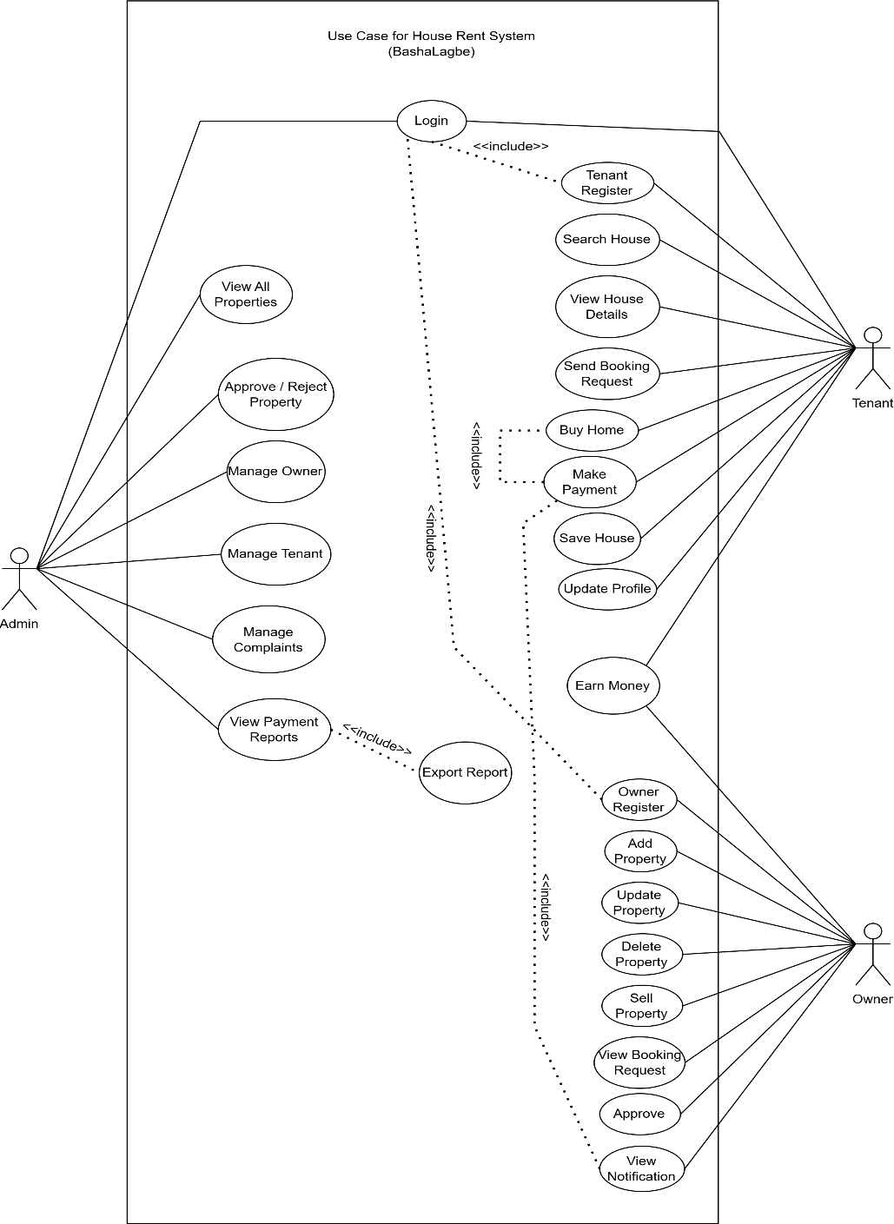

Fig 3.1 Use case Diagram

Chapter 4
Analysis

4.1 Software Analysis Pattern
For the development of the Online House Rent Finder System, the Model-View- Controller (MVC) Pattern has been used. The Model View Controller design pattern is a very common design pattern in web development, which separates the application logic into three parts:
• Model: Handles the data, business logic, and rules associated with the application, including database operations related to tenant, owners, flat listings, subscriptions, and payment transactions.
• View: Manages the user interface and presentation layer for tenant and admin dashboard pages, house browse pages, and transaction reports using HTML, CSS, and Bootstrap.
• Controller: It is an intermediary acting between user requests and model calls, processing user requests, processing needs from models, and updating views accordingly by utilizing scripts in PHP Laravel programming related to booking requests and validation from SSLCommerz payments. This separation of concerns ensures that the Online House Rent Finder Systemstays organized and scalable as a whole.
4.4.1 Why this Pattern?
The MVC pattern was chosen for the Online House Rent Finder System due to several key reasons:
Clear Separation of Concerns:
Each component (Model, View, Controller) is independent, allowing for easier development, testing, and maintenance of features like flat management and booking.
Scalability: When the platform grows, it is possible to introduce additional features, such as filtering, multi-city features, and live chat, without impacting the existing features and functionalities of the application.
Reusability of Components: Views and controllers. These components may be shared or reused when dealing with other modules, such as profile or booking history.
Effective Data Handling: This model deals with the database handling effectively, ensuring the optimal processing of confidential data such as user details and transactions.
Enhanced User Experience: Users experience smooth, real-time interactions—such as booking confirmation or payment status updates—without unnecessary page reloads.
Industry Standard: MVC is a widely adopted architectural pattern in professional web applications, aligning the system with proven best practices in software engineering.

4.2 ERD Diagram
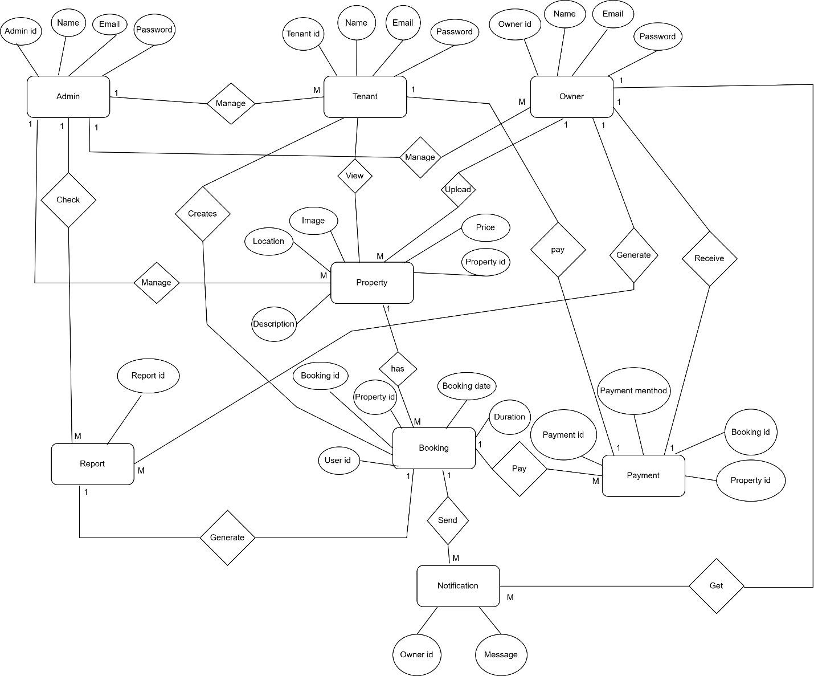
4.1 Fig ERD Diagram

4.3 Activity Diagram
4.3.1 Tenant login Diagram (Activity Diagram)

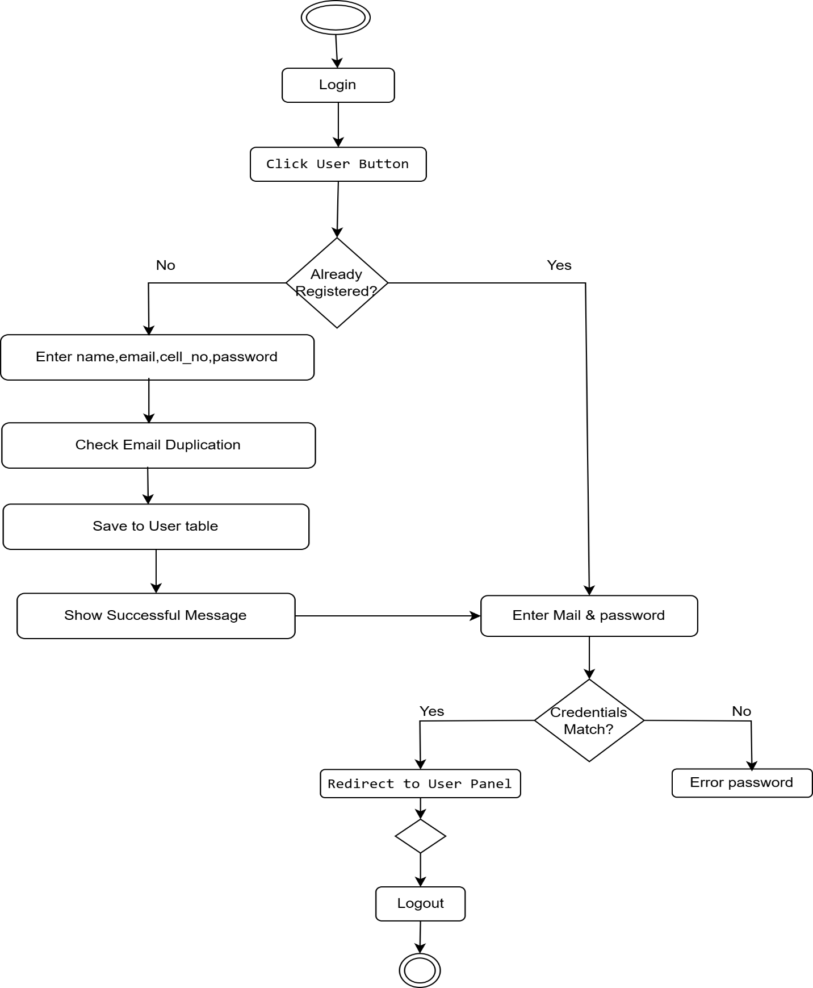

4.1 fig Tenant login Diagram (Activity Diagram)

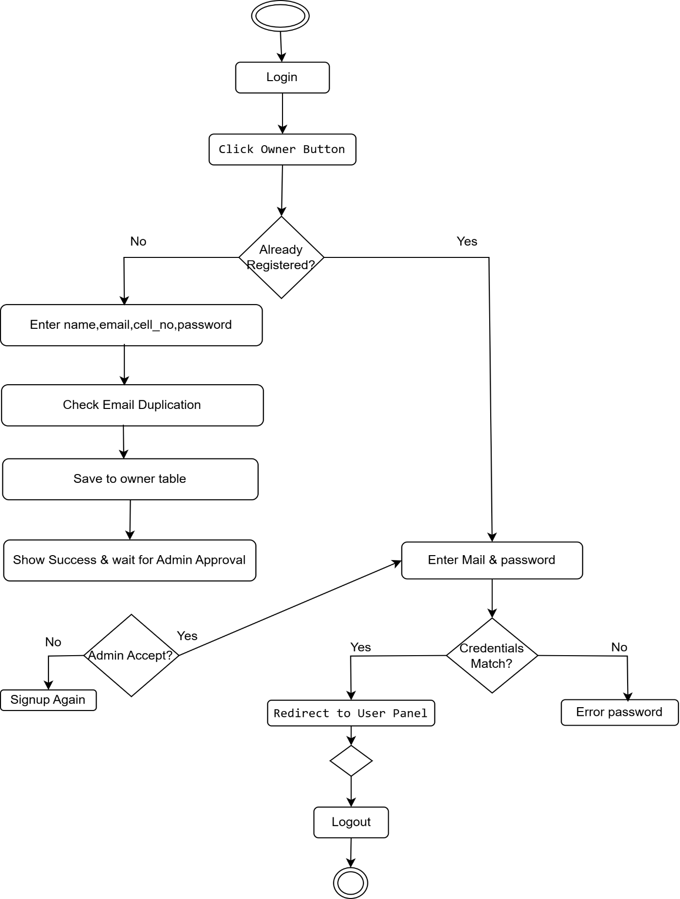

4.2 fig Owner Login Diagram
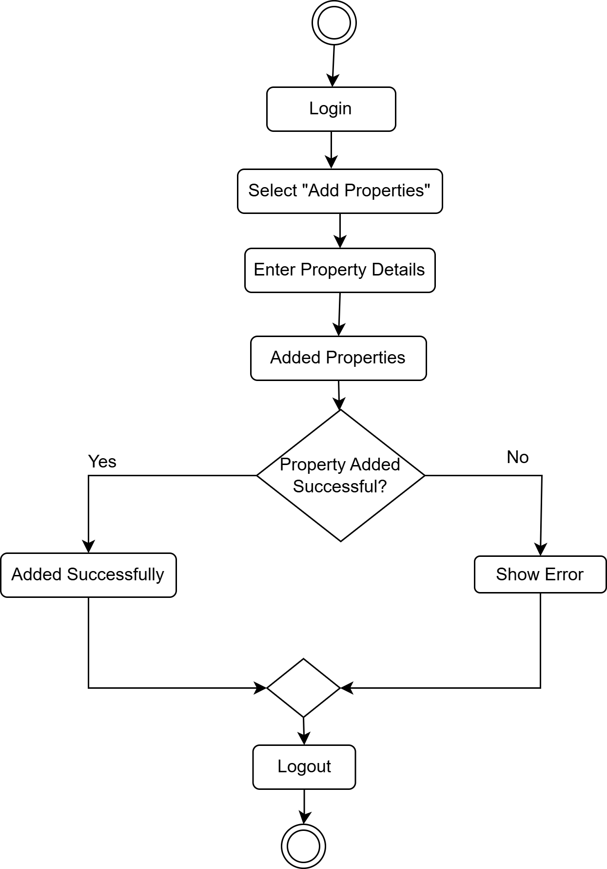

Fig 4.3 Owner Added House
4.4.2 Tenant house Search & Booking
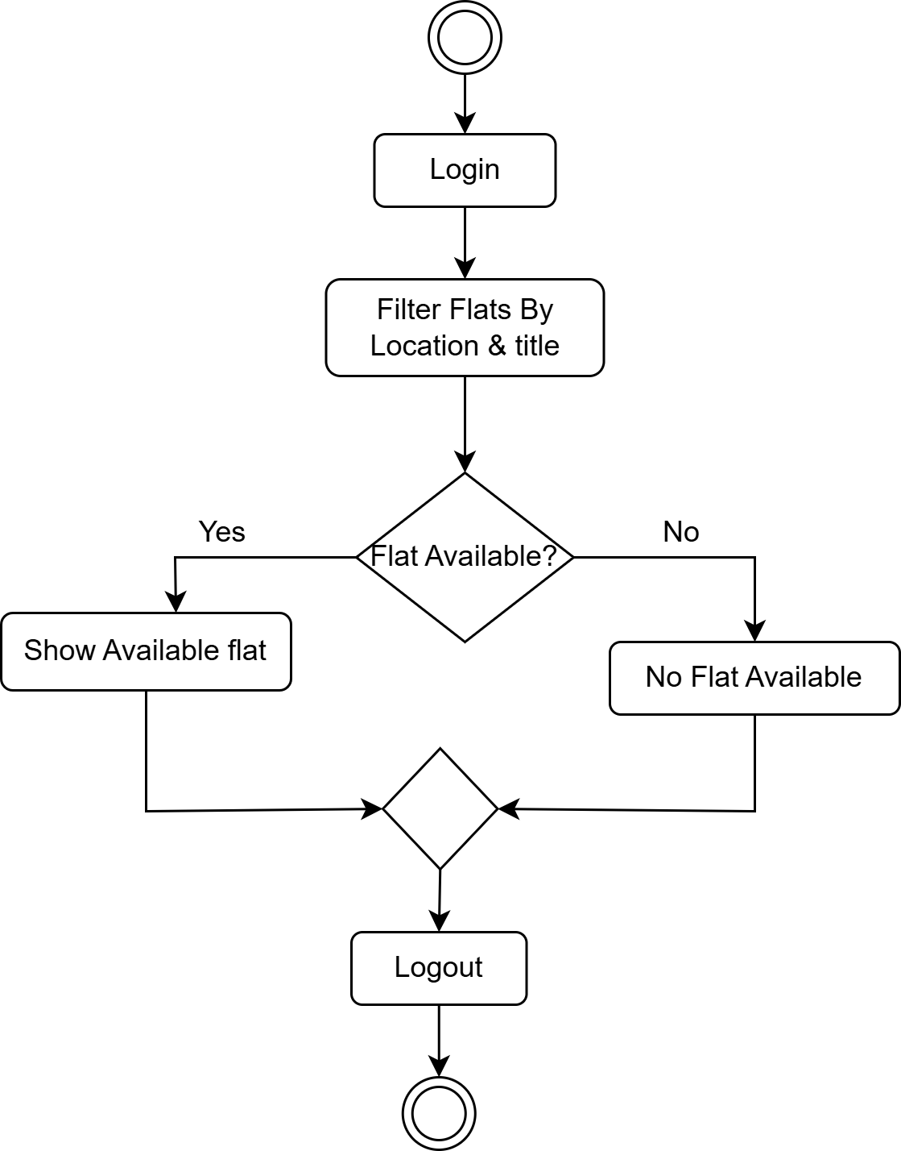

4.4 fig Tenant Search house with filtering
4.4.3 House Booking Payment
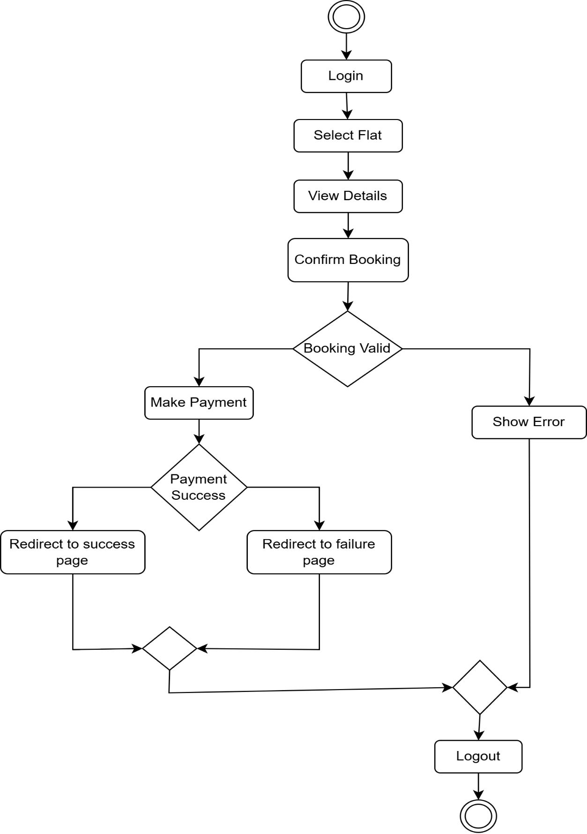

4.5 fig Flat Booking Payment
4.3.3 Owner House Management
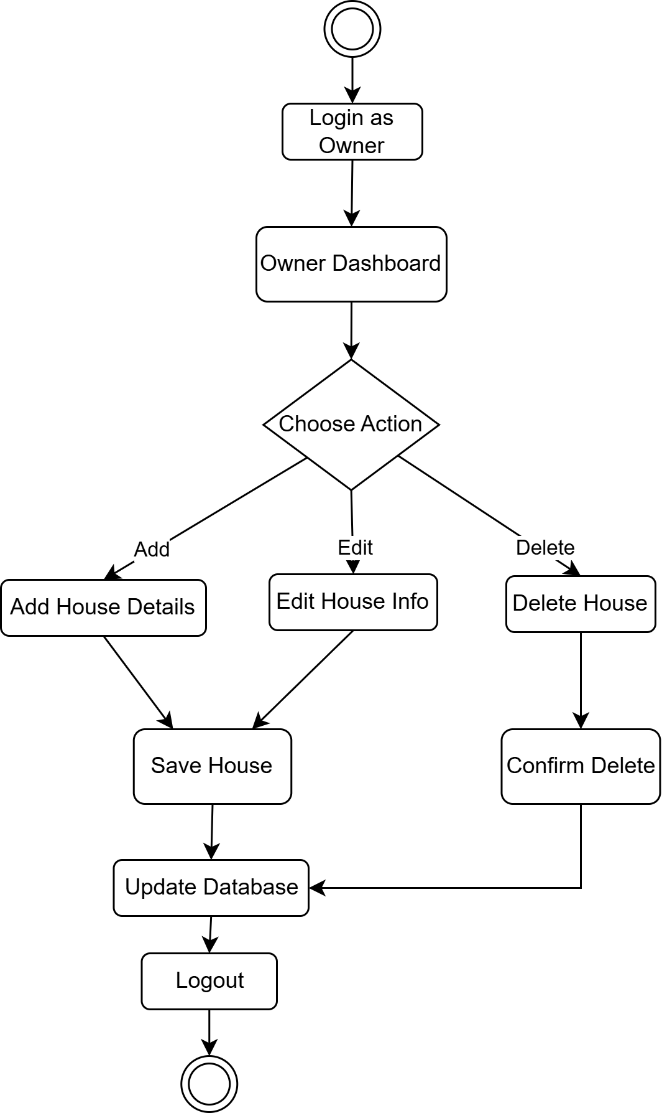

4.6 fig Owner House Management
4.3.5 Admin Control Process
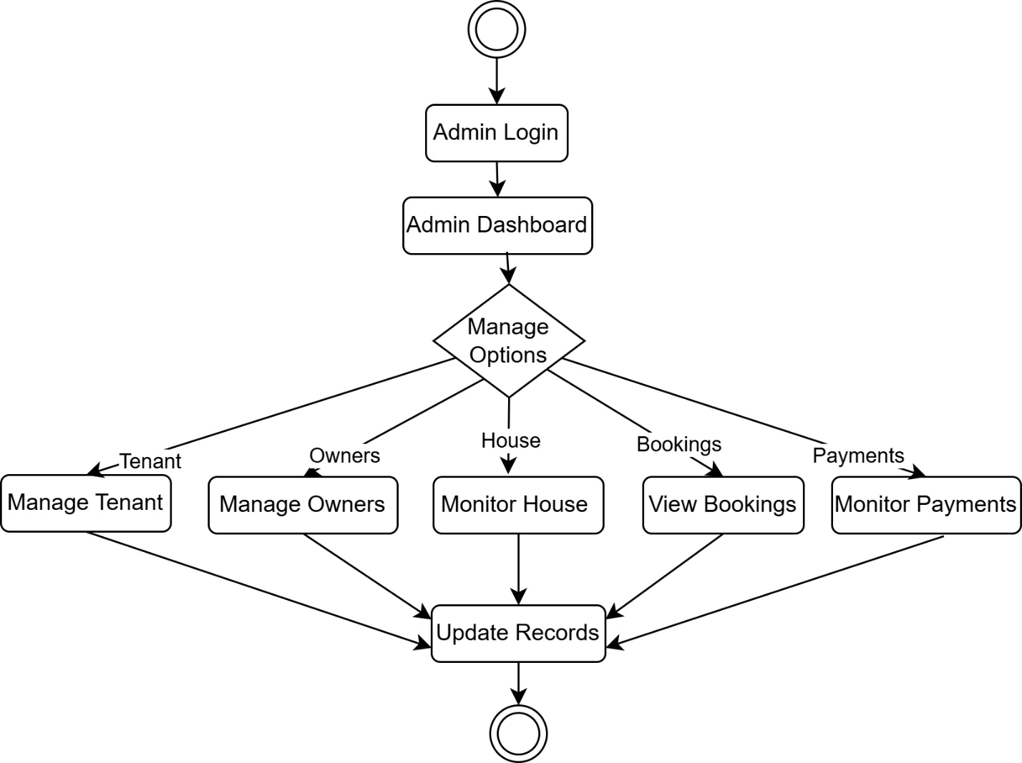

4.7 fig Admin Control Process

Chapter 5
Project management

5.1 Risk Identification Table
Risk ID | Risk Name | Category
R1 | System Downtime | Technical | Risk of server failure causing the House booking platform to be unavailable, especially during peak moving seasons.
R2 | Data Breach | Security | Unauthorized access to sensitive user information, house owner details, or payment credentials
R3 | Payment Gateway  Failure | Financial | Payment processing may fail, leading to transaction errors for house bookings and loss of revenue.
R4 | Incomplete  Requirements | Requirements | User requirements for house management, subscription plans, or booking features may be misunderstood.
R5 | User Resistance | Operational | House owners or tenants may hesitate to adopt the new online booking system.
R6 | Project Delay | Management | Technical challenges or resource shortages may delay the system launch.

Table 5.1: Risk analysis Table

5.2 Risk Analysis Table
Table 5.2: Risk analysis Table
Risk ID | Probability  (1–5) | Impact (1–5) | Risk Exposure  (P*I ) | Priority
R1 | 3 | 4 | 12 | High
R2 | 2 | 5 | 10 | High
R3 | 3 | 5 | 15 | Very High
R4 | 3 | 3 | 9 | Medium
R5 | 2 | 3 | 6 | Low
R6 | 3 | 3 | 9 | Medium

Probability Scale: 1 (Very Low) to 5 (Very High).
Impact Scale: 1 (Negligible) to 5 (Critical).
Priority: High (10+), Medium (7-9), Low (<7).
5.2 Risk Planning Table
Table 5.3: Risk Planning Table
Risk ID | Mitigation Strategy | Contingency Plan
R1 | Use reliable hosting with backup servers. | Switch to backup provider or  local deployment.
R2 | Implement SSL encryption and secure queries. | Conduct periodic security audits and patch flaws.
R3 | Use trusted payment gateways  with redundancy. | Allow manual verification or  alternative methods.

5.4 RMMM Plan
The Risk Mitigation, Monitoring, and Management Plan makes certain that any potential risks associated with the Flat Booking Management System are systematically found, analyzed, and controlled throughout the project life cycle. It deals with risks on three layers.
Mitigation: Proactive approaches ensured that the risks have less chance of materializing. To secure user and payment information, a secure payment subsystem via SSLCommerz was incorporated following proper security protocols. Adequate input validation, session handling, and role-based access controls ensured that no improper access and modification of data occur. SQL constraints and booking prevention for the same flat have been implemented to counter any conflict, like simultaneous booking of the same flat, and so on. Communication with the house owner was regularly maintained to ensure the correctness of the flat availability, price, and booking terms, among others, that may cause any error or misinformation.
Monitoring: Continuous monitoring methods were employed to identify threats at an early stage. System function and booking functions were also monitored on a continuous basis to ensure a smooth operation process. Payment transaction records were also monitored to identify any unsuccessful or late transactions. Authentication and access function records were examined to identify any unusual login access or potential threats to security. System project functions were examined periodically to identify any potential delays in the project, and booking functions examined to avert overbooking and any flat availability disparities.
Management: If risks were present despite the implemented risk mitigation and monitoring mechanism, the corresponding contingency measures were employed. If payment gateway risks were present, for instance, users were provided with an opportunity for repeated transaction attempts or using alternative verification procedures for payments. If system shutdowns or loss of data were present, database backup procedures were employed for risk response. If risks associated with new requirements or changes were identified, new requirements were documented and risked by applying updates in the system or prioritized tasks. Issues related to users were addressed by improving system usability, offering guidance, and obtaining user feedback. control and contributed significantly to the successful development and implementation of the Online House Rent Finder System.

Chapter 6
Project Planning and Scheduling

6.1 System Project Estimation

Module Name | Description | Estimated  time(hours)
User Authentication | User, owner, and admin registration, login, and role-based access control | 15
Flat Browsing & Search | View flat listings, search by location, price range, and house type | 12
Flat Details & Booking | Flat details view, booking request, availability check, booking confirmation | 20
Payment Gateway Integration | SSLCommerz integration, payment validation, transaction logging | 15
Owner Panel | Interface for owners to add, update, delete flats, and  manage booking requests | 25
Admin Dashboard | Management of users, owners, flats, bookings, and  payments | 35
Backend Processing | Database design, PHP server-side logic, validation, error handling | 20
UI & UX Design | Frontend layout, responsive design, user interaction flow | 15
Testing & Debugging | Functional testing, booking and payment testing, bug fixing | 13
Total Estimated Hours |  | 170
Table 6.1: System Project estimation

Construction of the Flat Booking Management System needs efficient planning in terms of not only the development process, but also in estimating the size of the system and the complexities involved in the project itself. In this chapter, the size of the system has been measured in terms of function points, and the complexities of various parts of the project have been determined, and unadjusted and adjusted function points have been calculated to get a fair estimate of the project. This systematic planning process helped in identifying the project goals and resource allocation, which aided in the development process during the practicum. It also helped in having a clear understanding of the system scope, which led to the successful implementation of the project.
6.2 Function-Oriented Metrics
To measure system complexity, Function Point Analysis (FPA) is applied to the Flat Booking
System:
External Inputs (EI): User registration, flat booking details, and owners adding property listings.
External Outputs (EO): Booking confirmation messages and automated system reports.
External Inquiries (EQ): Property search functionality and viewing personal booking or payment history.
Internal Logical Files (ILF): Primary database tables for users, flats, bookings, and payments.
External Interface Files (EIF): Integration with external APIs like the SSLCommerz payment gateway.
6.3 Identifying Complexity
6.3.1 Identifying Complexity of Transition Function
Table 6.2: Identifying Complexity of transition Function
Function | Type | DET | FTR | Count | Complexity | FP
User Registration  & Login | EI | 4 | 2 | 1 | Medium | 4
Owner Registration  & Login | EI | 4 | 2 | 1 | Medium | 4
Add Flat Information | EI | 8 | 3 | 1 | High | 6
Update Flat Information | EI | 6 | 2 | 1 | Medium | 5
View Flat Listings | EQ | 6 | 2 | 1 | Medium | 5
Search Flat | EQ | 8 | 3 | 1 | Medium | 7
Flat Booking | EI | 7 | 3 | 1 | High | 6
Booking Data Storage | ILF | 7 | 3 | 1 | High | 6
Process Payment | EO | 5 | 2 | 1 | High | 4
View Payment History | EQ | 6 | 2 | 1 | Medium | 5
View Booking History | EQ | 6 | 2 | 1 | Medium | 5
Manage User Profile | EI | 4 | 1 | 1 | Low | 3
View Booking Details | EQ | 6 | 2 | 1 | Medium | 5
6.3.2 Identifying Complexity of Data Functions

Table 6.3: Identifying Identifying Complexity of Data Functions
Data Function | Type | DET | RET | Count | Complexity | FP
User | ILF | 6 | 2 | 1 | Medium | 10
Owner | ILF | 5 | 2 | 1 | Medium | 10
House | ILF | 8 | 2 | 1 | Medium | 10
Booking | ILF | 7 | 2 | 1 | Medium | 10
Payment | ILF | 6 | 1 | 1 | Medium | 10
Admin | ILF | 5 | 2 | 1 | Medium | 10
Location / Area | ILF | 4 | 1 | 1 | Medium | 10
Flat Images | ILF | 6 | 1 | 1 | Medium | 10

6.3.3 Unadjusted Function Point Contribution (Transaction Functions)
The transaction function points were calculate based on all identified EI, EO, and EQ functions
of the Flat Booking Management System.
Total Transaction Function Points:
= 4 + 4 + 6 + 5 + 5 + 7 + 6 + 6 + 4 + 5 + 5 + 3 + 5
= 66
6.3.4 Unadjusted Function Point Contribution (Data Functions)
The data function points were calculated based on all identified Internal Logical Files (ILF)
used in the system.
Total Data Function Points:
= 10 + 10 + 10 + 10 + 10 + 10 + 10 + 10
= 80
Total Unadjusted Function Points (UFP)
Total UFP=Transaction FP+Data FP
Total UFP=Transaction FP+Data FP
= 66 + 80=146

6.3.5 Performance and Environmental Impact Performance Considerations
• The system should providing real-time updates on flat avilability and instant booking confirmation to ensure accuracy and user satisfaction.
• The integrated payment gateway (SSLCommerz) should process transactions securely with minimal latency to ensure smooth and reliable payment operations.
• Flat search and filtering options (such as location, price range, flat type, and availability) must return results within 1–2 seconds to provide a seamless user experience.
• Administrative operations, including adding, updating, or removing flat listings, users, or owners, should be reflected immediately in the system to maintain data consistency.
• Owner-related actions, such as updting flat availability, approving or rejecting booking requests, and managing listings, must be processed efficently without noticeable delays.
6.3.6 Counting Adjusted Function Point
The Adjusted Function Point (AFP) of the Flat Booking Management System was calculated by considering the system’s technical and environmental characteristics. These characteristics include online payment processing, real-time flat availability updates, role-based access control, database interaction, and security requirements.
Sum of Rating (ΣFi):
ΣFi = 46
Calculation of Technical Complexity Factor (TCF)
TCF=0.65+(0.01×ΣFi)
TCF=0.65+(0.01×46)
TCF = 0.65 + 0.46 = 1.11
Adjusted Function Point (AFP)
AFP=UFP×TCF
AFP=146×1.11=162.06≈162AFP
Effort Calculation Based on Adjusted Function Points
Average effort per Function Point: 5 person-hours per FP
Total Effort (Person-Hours):
Effort=162×5=810 per hours

6.4 Project Schedule Chart:
Table 6.4: Project Schedule Chart
Phase | Task | Duration
Planning | Requirement Analysis & System Engineering | Day 1 – 5
Design | System Architecture & UI/UX Design | Day 6 – 11
Implementation – Part 1 | Backend Development, Authentication, Flat Booking Logic | Day 12 – 23
Implementation – Part 2 | Admin Panel & Owner Panel Development | Day 24 – 33
Implementation – Part 3 | Frontend Components, User Pages, Responsive Design | Day 34 – 43
Payment Integration | SSLCommerz Payment Integration & Validation | Day 44 – 48
Testing & Quality  Assurance | Functional Testing, Booking & Payment Testing, Bug Fixing | Day 49 – 54
Deployment | Final Deployment & User Feedback Collection | Day 55 – 57
Buffer | Unplanned Delays and Final Adjustments | Day 58 – 60

6.5 Accounts Table
6.5.1 Personnel Cost
Table 6.5: Personal Cost
People/items | Description | Cost
Developer | developers cost for 1 | 24000 tk.

6.5.2 Expected Hardware Cost
Table 6.6: Hardware Cost
Items | Description | Cost
Personal Laptop | Used personal laptop,sometimes  organizations pc | 0tk.
Testing Devices | Organizations pc | 0tk.
Storage Device | Installed USB drive in laptop | 700 Tk.
Networking Devices | Wi-Fi Router | 2500 Tk.

6.5.3 Expected Software Cost
Table 6.7: Software Cost
Items | Description | Cost
Hosting | Free Hosting on Vercel | 0 tk.
Development Tools License | No tools needed licence | 0 tk.
OS | Used Laptops pre-installed windows | 0 tk.
Payment gateway | Used Stipe in developer friendly way | 0 tk.

6.5.4 Expected Other Cost
Table 6.8: Other Cost
Items | Description | Cost
Documents | Printing Logbook, manual, project report | Approximate 500Tk
Internet | Broadband connection | 1000 Tk
Mobile Data | Sometimes mobile data was required | 300 Tk

Total Cost = (24000+ 700 + 2500 + 500 + 1000 + 300 ) Tk.
=29000 TK

Chapter 7
Designing

7.1 Home Page
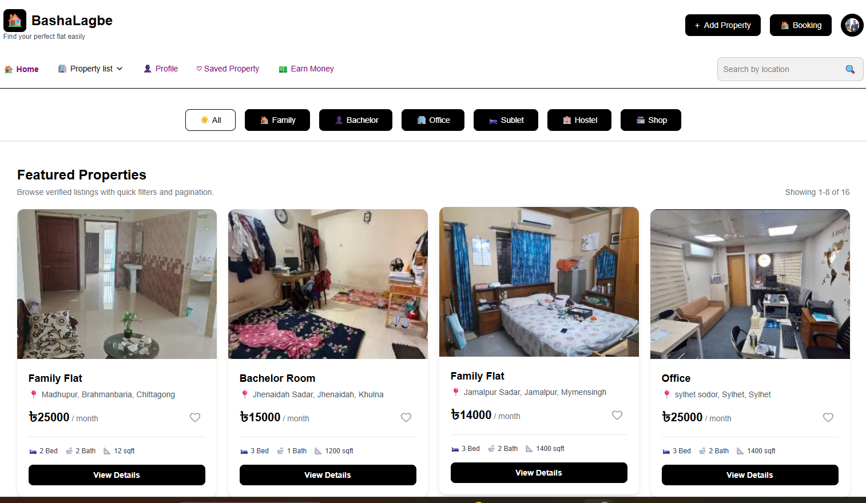
Fig 7.1.1 Home Page
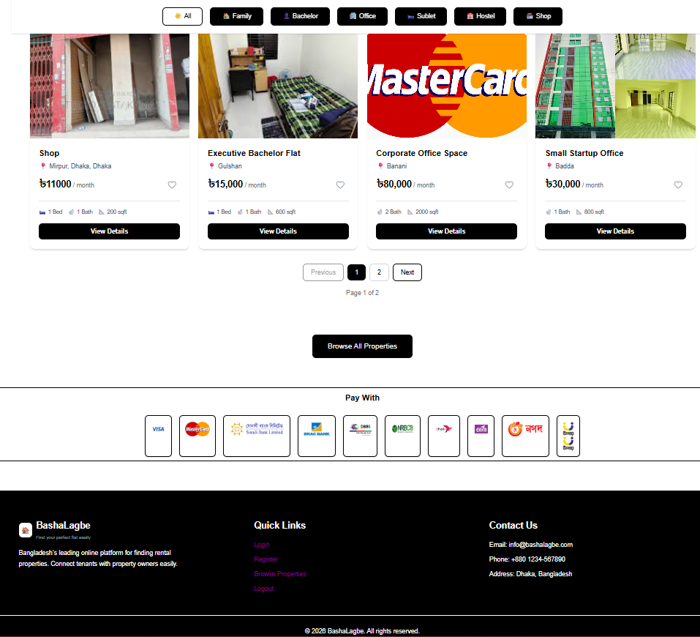

Chapter 8
System Quality and Testing

A Quality Management System (QM System) is a systematic structure of processes, specifications, and responsibilities that are designed in such a manner that the software application works efficiently in terms of delivering high-quality results. In the context of the Online House Rent Finder System, the QMS targets the reliability, security, usability, and performance of the system in various user processes involving administrators, owners, and users.
8.1. System Quality
The aim of the quality management of the system quality for the Flat Booking Management System is to ensure the creation of a safe and reliable environment for the management of the house booking and online payment services. Such a system is expected to ensure proper house booking and online payment services by providing the relevant measures for ensuring the safety and efficiency of these aspects. It is imperative to ensure high quality is maintained in such aspects.
8.1.1 Software Quality Management Process
To ensure that the quality of the software is maintained at every stage of the developing process, a structured quality management process was adopted:
• Requirement Traceability: The functional requirements of searching flats, booking, and payment for users, owners, and administrators to track and manage users, bookings, and payments, respectively, were traced to distinct system modules.
• Test-Driven Approach (Partially Applied): In certain important functionalities, like flat booking confirmation and online payments, test scenarios were designed prior to testing, which resulted in a reduction of functional defects.
• The features of the system were developed and tested incrementally using a manual testing approach in order to confirm that a given input, output, and system behavior indeed work as expected before moving on to the next stage of system development. The system passes through each stage before moving on. The stages involved are each system module review.
Security Assurance: User authentication data was protected using encryption and session management techniques. Role-based access control was enforced to prevent unauthorized access, such as users attempting to access admin or owner functionalities.
Error Handling: The system was tested against edge cases, including invalid form submissions, unauthorized access attempts, and booking conflicts caused by unavailable house, to ensure proper error messages and system stability.
Code Review and Refactoring: Regular self-review of code was conducted to improve readability, maintainability, and logic optimization, particularly for booking validation, database queries, and payment handling modules.

8.2 Software Test Cases
Here are sample test cases from key modules of the Online House Rent Finder System:
Test Case ID: TC001
Test Priority: High
Module Name: User Registration & Login
Description: Ensure that a new user can successfully register with valid information and log in to the system.
Precondition: The user is not already registered in the system.
Dependencies: None
8.1 Test Case 1
Step | Test Steps | Test Data | Expected  Result | Actual Result | Status
1 | Go to  registration  page | N/A | Registration  page loads  successfully | Registration  page loaded | Pass
2 | Enter valid  email | owner2@gmail.com | System accepts  valid email | Email  accepted | Pass
3 | Enter  password | 12345678 | System accepts  password | Password  accepted | Pass
4 | Enter your  phn number | 01749240754 | System accepts  phone number | Phone number  accepted | Pass
5 | Click on  Register  button | N/A | Success message  is displayed | Success  message  displayed | Pass
6 | Navigate to  login page | Check database | User data is  found | User data  found | Pass
7 | Attempt to  login | owner2@gmail.com | Redirect to user  home page | Navigated to  home page | Pass

Test Case ID: TC002
Test Priority: High
Module Name: Owner Panel – Add Flat
Description:
Verify that an Owner can successfully add a new flat with all required information.
Precondition: Owner is logged in and has access to the add_flat.php page.
Dependencies : Database connection is active.
8.2 Test Case 2
Step | Test Steps | Test Data | Expected Result | Actual Result | Status
1 | Go to Add Flat  page | N/A | Add Flat page loads successfully | Add Flat page  loaded | Pass
2 | Enter house title | Sunshine  Apartment | System accepts flat title | Flat title  accepted | Pass
3 | Enter house rent | 6000 | System accepts rent amount | Rent amount  accepted | Pass
4 | Enter house location | Uttara, Dhaka | System accepts  location | Location  accepted | Pass
5 | Upload house image | house.jpg | Image selected  successfully | Image uploaded | Pass
6 | Click on Add  Flat button | N/A | Success message is displayed | Success  message  received | Pass

Chapter 9
Ethical Consideration

9.1 Ethical Considerations in the Software Development Process
The development of the Online House Rent Finder System, which maintains user information, booking records, and online payments, carries with it a variety of ethical responsibilities. Ethical principles have been upheld at each milestone of development from system design to final deployment, in order to ensure responsible and trusted software development.
9.1.1 Data Privacy and Security
The personal details of the user, such as names, emails, phone numbers, and booking details, are considered to be sensitive information. The passwords of all the users are securely maintained by encrypting and hashing them, and authentication and sessions are managed to ensure secure system access. The sensitive payment info is also not saved in the system, and all payment transactions take place through SSLCommerz to ensure payment security norms are followed.
9.1.2 Intellectual Property
Every aspect of this project, including design, PHP, MySQL, HTML, CSS, Reast, as well as other open-source software, has been developed independently as part of this practicum. Proprietary software or code from other sources, if used, is not violated. Open-source software is utilized appropriately. Bootstrap, PHP, MySQL, Laravel, CSS, HTML, among other open-source software, are all used appropriately.
9.1.3 User Impact
The system was developed with user convenience and transparency at its focus. Elements like house availability status, booking information, and payment history enable the user to make informed decisions. The booking rules and confirmation notifications enable the user to comprehend the booking process, resulting in a reliable and user-friendly experience for the ten-ants, owners, and administrators.
9.1.4 Bias and Fairness
The Flat Booking Management System provides equal functionality and access to all users based on their assigned roles. The system does not favor any user in terms of booking availability, pricing, or approval processes. Booking decisions are handled in a fair and time-based manner, ensuring neutrality and preventing discrimination among users.
9.1.5 Responsibility to Stakeholders
The system was developed with user convenience and transparency at its focus. Elements like house availability status, booking information, and payment history enable the user to make informed decisions. The booking rules and confirmation notifications enable the user to comprehend the booking process, resulting in a reliable and user-friendly experience for the ten-ants, owners, and administrators.
9.1.6 Professional Responsibility
As a student developer and aspiring software engineer, I followed professional standards throughout the development process. This included writing clean and organized code, validating user input, implementing proper error handling, and maintaining consistent coding practices. Version control techniques and regular testing were used to improve reliability, and no shortcuts were taken that could negatively affect the system’s quality or maintainability.
9.1.7 Sustainability in the Software Development Process
Sustainability was an important consideration during the planning and development of the Online House Rent Finder System. The system was designed to support long-term usage while minimizing technical and operational overhead.
9.1.8 Economic Sustainability
To ensure cost efficiency, the system was developed using open-source technologies such as PHP and MySQL, Laravel, eliminating the need for expensive software licenses. Development and testing were carried out using local server environments like XAMPP or Laragon, which further reduced costs. Payment integration was implemented using the sandbox environment of SSLCommerz, allowing secure testing without additional financial burden.

Chapter 10
Conclusion

10.1 Brief Overview of the Project
The Online House Rent Finder System is a web-based application developed to simplify and automate the process of flat booking and rental management. The system enables users to search available flats, view detailed information, place booking requests, complete online payments, and track their booking history. On the administrative side, the platform provides a centralized dashboard for managing flat listings, users, owners, bookings, and payment records. The project was implemented using PHP, Laravel, MySQL, HTML, CSS, and JavaScript, with emphasis on usability, data accuracy, and system security.
Proposed System Benefits Simplified Booking Process: It is easier for customers to view apartments, search for apartments according to location and price, and submit booking requests.
Online Secure Payment System: The transactions performed on this online payment system are secured through SSLCommerz, resulting in a reliable and trustworthy system.
Administrative Control: The administrators have the ability to control the flat listings, monitor bookings, check payments, and review the actions of the users.
User experience improvements: Facilities like booking history, payments history, and availability of flats enable greater transparency and user experience.
Scalability: Its results in a scalable architecture, which provides extensions and integration with other platforms in the future.
10.2 Limitations of the Project
Web-Based Only: The system is currently accessible only through web browsers and does not have a dedicated mobile application.
Limited User Roles: The system supports Admin, Owner, and User roles; advanced role customization is not yet implemented.
Basic Error Handling: Although core validation exists, advanced logging and monitoring mechanisms are not included.
Single Currency Support: The payment system operates in a single currency, with no support for multi-currency transactions.
10.3 Practicum and Its Value
This practicum provided valuable real-world experience in designing and developing a complete web-based system. Through this project, I gained practical knowledge in database design and normalization using MySQL, implementing secure authentication and role-based access control, integrating online payment services, and developing dynamic web applications. Beyond technical skills, the practicum strengthened my problem-solving ability, independent working skills, and understanding of professional software development practices.
10.4 Future Plan
Public Deployment: Deploy the Flat Booking Management System for real-world usage with actual flat listings and users.
Mobile Application Development: Develop a mobile application using frameworks such as Flutter or React Native to improve accessibility.
Notification System: Add email and SMS notifications for booking confirmations, approvals, and payment updates.
Reporting and Analytics: Implement analytical tools for administrators to track bookings, revenue, and user activity.
Security and Performance Enhancements: Introduce features such as two-factor authentication, rate limiting, and server optimization for improved security and performance.

References
IEEE Computer Society. (n.d.). Code of ethics for software engineers. Retrieved September 24, 2025, from
https://www.computer.org/education/code-of-ethics
Laplante, P. A., & Kassab, M. (2022). Requirements engineering for software and systems (4th ed.). New York, NY: Routledge. Wiegers, K., & Beatty, J. (n.d.). Software requirements. Retrieved September 24, 2025, from
https://argondigital.com/software-requirements-books/
Pressman, R. S., & Maxim, B. R. (2020). Software engineering: A practitioner’s approach (9th ed.). New York, NY: McGraw-Hill Education.
ProjectManager. (2025). Top project management methodologies: An overview. Retrieved September 24, 2025, from
https://www.projectmanager.com/blog/project-management-methodology
Park University. (2024). From agile to waterfall: A breakdown of project management methodologies. Retrieved September 24, 2025, from
https://www.park.edu/blog/from-agile-to-waterfall-a-breakdown-of-project-managementmethodologies/
Al-Masree, A., & Al-Shamri, A. (2021). Development of a database-driven rental management system: ER model and implementation. ResearchGate. Retrieved September 24, 2025, from
https://www.researchgate.net/
Rahman, M., & Hossain, M. (2022). Design and implementation of a web-based property rental management system. International Journal of Computer Applications, 174(18), 25–31. SSLCommerz. (n.d.). SSLCommerz payment gateway integration documentation. Retrieved September 24, 2025, from
https://developer.sslcommerz.com/
W3Schools. (n.d.). PHP, MySQL, HTML, and CSS tutorials. Retrieved September 24, 2025, from
https://www.w3schools.com/

